CSE670 Project
Names Date

Online Bookstore Project

Bits & Books needs a simple information management system and database to support their inventory and sales operations. This specification will provide you with many of the user requirements, however you may want to supplement your solution with features that you consider important or interesting.

Your final document will include a relational database schema, entity relationship diagram, SQL queries, input forms and reports.

- Test data: You will receive the book data file (fig 1). You will need to create your own customer and other data. You should put enough test data into your database in order to run the sample queries and test the scenarios. It is important that you have enough test data to (1) generate reasonable results for each of the scenarios described at the end of this document; and (2) generate good reports. For example, some of the reports require computing total; in that case you should not only return one data row.

Figure 1. Book Data in .xls format (available on Carmen)
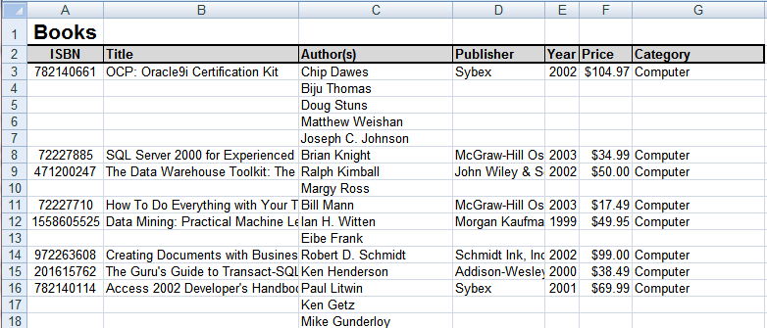

b) Test Scenarios:
The database should be able to support the usual operations of an online bookstore. That is, that users may browse for books, make purchases and review their accounts. An administrator should be able to review sales and see what books need to be reordered from the publisher.

Worksheet 00 – DB Concepts
- What tables and fields might need to be included in the database?
Book
id | isbn | publisher | date | cost | price | category
Category
id | name
Book_Category
id | book_id | category_id
Author
id | name | birth_date
Publisher
id | name | city
Book_Author |  |  |  | Cart
id | book_id | author_id |  | id | user_id | status | order_id
Book_Publisher
id | book_id | publisher_id
Inventory |  |  |  |  | CartItem
id | book_id | quantity | status |  | id | book_id | cart_id | quantity
InventoryOrder
id | cost | orig_quantity | cur_quantity
Order
id | user_id | billing_id | address_id | subtotal | shipping | tax | status
OrderItem
id | order_id | book_id | price | cost | status
User
id | name | address_id | phone_number | last_login | join_date | password | email
UserAddress
id | name | user_id | address_1 | address_2 | city | state | zip | country | status
Billing
id | name | cc_number | sec_number | exp_date | address_id
 | *every table will also have an creation date and a modified date
Publishers – name, location
- Books – name, author(s), publish

- er, date, ISBN…
- Authors – name
- What informal queries and update operations that might users expect?
Look up order status, search by category, search by title, search by author, add item to cart, remove item from cart, look up number in stock, make order to publisher, add billing info, change billing info, remove billing info

- What kind of reports might be desired by the users?
View inventory, see profits on a book, see top books sold, view places delivered to

- Give some examples of integrity constraints that you think can apply to the database.
Every id is an integer; every field with an underscore is an integer; price, shipping, tax, subtotal are floats; status fields are strings; quantity fields are integers; if an OrderItem price is updated, the order subtotal, shipping, and tax must be updated; user_id in and Order must map to a valid user

- If the a customer changes their address, what would need to be updated? What other changes could affect the data and relationships between the tables?
If the user has pending orders, and the address has not been used for a previous order, then only the address would need to be modified. Otherwise, a new address needs to be created, and the old address status needs to be set to out of date.

Worksheet – 01 Entity-Relationship (ER)
Provide an ER diagram for your database

Worksheet –02 Enhanced ER (EER)
Are there any hierarchical relationships in the database? If so, what are they? Think of at least two hierarchical relationships you can add to the database.

Refine your ERD to show these new relationships.

Worksheet – 03 Relational Data Model
Propose ten Update operations that could be applied directly to the database. For each discuss all integrity constraints violated by each operation, if any, and the different ways of enforcing these constraints:
 | Operation | Integrity constraints

Worksheet –04 EER to Relational Mapping
Map your EER to a relational schema and show all primary and foreign keys.

Worksheet – 05 SQL
- What are the referential integrity constraints that should hold on the schema?

- What tables do you think should be included? What fields?

- Write appropriate SQL DDL statements to define the database.

Worksheet – 05 More SQL
Specify the following queries and show a sample results for the database.
- Find all of the books by Asimov that cost less than $5
- SQL

- Sample Result

- Give all of the titles and dates for purchases made by a particular customer.
- SQL

- Sample Result

- List all of the books with less than 5 quantity in stock.
- SQL

- Sample Result

Worksheet – 06 Relational Algebra
Show schema for your database that you have so far. Indicate relationships, and foreign keys using the “arrow” notation from the book

Specify the following queries in relational algebra.
- Find all of the books by Asimov that cost less than $5

- Give all of the titles and dates for purchases made by a particular customer.

- List all of the books with less than 5 quantity in stock.

Worksheet –07 Normalization
Is your database fully normalized? Why or why not?

If not, restate your schema in 3NF

What to turn in.
- All worksheets
- The mysql database, with at least twenty records of sample data in each table.
- A database description document, including
  - Your fully normalized relational schema for the database.
  - Your SQL to create the database and execute the three sample queries.
  - SQL for three additional queries and reports that you think are interesting and demonstrate the features of the database. For example, inventory by publisher, orders by author, etc.
- A user manual describing how to
  - access the database
  - add a record
  - run a saved query

